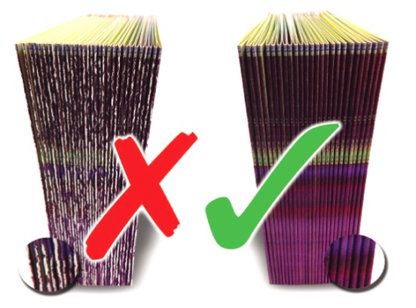

We guarantee to eliminate all of these problems using our new patented devices.
BOOK YOUR FREE DEMONSTRATION NOW
and pay nothing for our unique finishing accessory worth £50
- Is fibre cracking a constant threat to your folding, stitching and binding work?

- Do you feel let down by inadequate scoring, cutting and perforating tools that give poor results, time and time again?
Call 01455 554491
www.technifold.com
Tel: 01455 554491 Fax: 01455 554526 Email: lee.white@technifold.co.uk
Tech-ni-Fold, Unit 2, St John’s Business Park, Lutterworth, Leicestershire, LE17 4HB, UK

